2024-2025 PSYCHIATRY STANDARDIZED LETTER OF RECOMMENDATION

Applicant
Name: Casey Jones
ERAS ID: 1234
☒ The applicant has waived their right to view this letter, and this was discussed with them.

Letter writer
Name: Elliot Reid Dorian, MD
Title: Assistant Professor, Clerkship Director
Institution or Organization: Sacred Heart Hospital School of Medicine
Contact information: Elliot.reid@sacredheart.edu
The number of medical students you worked with in the past year: approx. 130

Provide a brief description of your relationship to the applicant such as clinical supervisor (observership, clerkship, elective) vs. research mentor, and include the duration of time worked together.
250 Character Max
I have mentored Mr. Jones since he was a first-year medical student. He worked with me clinically on our consult service as an M4 elective for one month and during his M3 psychiatry clerkship for two weeks.

Part 1:
Please use specific examples to describe the applicant’s qualities.

Qualities: CHOOSE ONE OR MORE (1) Communication/interpersonal skills (2) Interest/motivation for psychiatry (3) Teachability (open to and learns from feedback) (4) Honesty (5) Capacity to reflect/self-awareness.
1000 Character Max
Mr. Jones exhibits all of these qualities needed to be successful in psychiatry. Of these skills, there are two that stand to the level of being exceptional. The first one is his capacity to reflect and his self-awareness. Before coming into medicine, he worked as a special education teacher in a school for behavioral needs children. He saw how essential mental health is growing up in a rural community and seeing what occurs when there is no access to health care. These life experiences have provided him with an amazing ability to self-reflect and ask why a system is currently the way it is and how it should be to help those for whom it was designed.
The other exceptional quality exhibited by Mr. Jones is his passion for psychiatry. Growing up in a rural, underserved community and as a member of the LGBTQ+ community he has seen the unique mental health challenges that these communities face and the importance of culturally appropriate care. He has spoken to me many times about the benefit of psychiatric interventions when they are done well. His passion was also reflected through his work in our student clinic and with our curriculum committee to enhance our LGBTQ+ curriculum content.

Part 2:
Please use specific examples to describe the applicant’s clinical skills. Non-clinical letter writers should comment on these or similar skills in the context of their work environment.

Clinical Skills: CHOOSE ONE OR MORE (1) Ability to develop rapport with patients (2) Ability to work well in a clinical team (3) Ability to take a psychiatric history (4) Ability to perform a mental status exam (5) Ability to perform appropriate triage of medical and psychiatric urgent/emergent issues.
1000 Character Max
As the clerkship director for his core psychiatry clerkship, and site director, I was able to work closely with Mr. Jones in clinic and discuss his clinical skill with other preceptors. My colleagues and I agree that his clinical skills are superb and that he functioned at a much higher level than the typical student. His awareness of the patient’s emotional state and nonverbal cues allowed him to be able to ask and gather a complete and appropriate psychiatric history. As an example, one patient was not speaking to any of our team members yet, through Mr. Jones repeated attempts, the patient was able to speak with us and we were finally able to make a comprehensive care plan for this patient.
Mr. Jones displayed is his ability to work well in a clinical team. He was a leader for the clerkship students during his sub-internship, taking time to help the M3s to enhance their skills. He was a superb communicator- effectively gathering collateral and communicating changes in care plan to our social workers and primary teams. He took care to speak with patients’ nurses and gave appropriate deference to our team’s resident who spoke very highly of Mr. Jones as well.

Part 3:
Summarize the applicant’s preparedness/suitability for psychiatric residency.
Address such topics as:
- Characteristics that make this applicant unique relative to other applicants, such as their sense of duty, teamwork, perseverance, and ability to handle adversity.
- A description of how much guidance this applicant may need as they begin residency in comparison to their peers.
- Any additional information about the applicant you feel would be useful for program directors.
1000 Character Max

Mr. Jones is an exceptional student who will make a fantastic psychiatrist. Mr. Jones has had an interesting life and is not a traditional medical student. He brings a unique lens to care with his experience as a special education teacher, where he worked closely with students and their families to optimize learning where poor student mental health often was a barrier. This, along with his experience growing up in a rural community and being part of the LGBTQ+ community, give him a unique worldview that will add greatly to any program he is matched into. He has extensive experience working in stressful environments and delicate situations, a necessary skill in psychiatry. He is more than prepared to start residency.

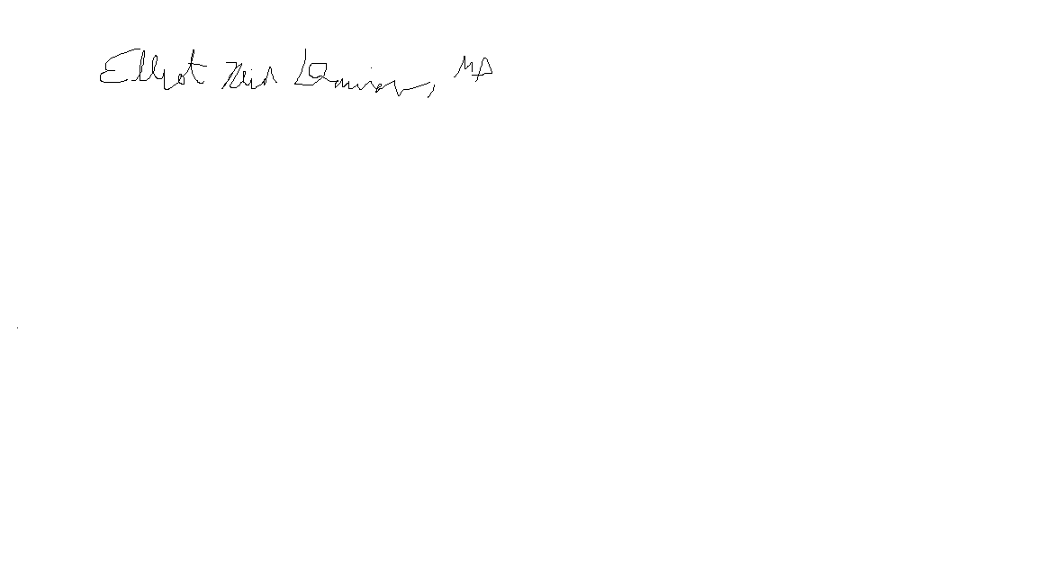
Signature and date:

Elliot Reid Dorian, MD
Assistant Professor
Clerkship Director
Department of Psychiatry
Sacred Heart School of Medicine

